Bismillahir Rahmaanir Raheem

Importance of Hijab in Women Empowerment

As Salaamu Alaikum wa Rehmatullaahi Wa Barakatahu

The purpose of this Seminar is to spread awareness about empowerment of women in human society, and bring together people with similar outlook so that a revolution can be sparked and a change can be initiated. The society needs superhero to stand against the social evil. However such superhero exist only in the books. In reality, its the common man who can bring the change by standing up for the women and their rights.

Empowerment of women is essentially the process of upliftment of economic, social and political status of women, the traditionally underprivileged ones, in the society. It involves the building up of a society wherein in women can breathe without the fear of oppression, exploitation, apprehension, discrimination and the general feeling of persecution which goes with being a woman in a traditionally male dominated structure.

A Muslim woman may wear whatever she pleases in the presence of her husband and family or among women friends. But when she goes out or when men other than her husband or close family are present she is expected to wear a dress which will cover [her hair and] all parts of her body , and not reveal her figure.

Today people think that women are liberated in the West and that the women's liberation movement began in the 20th century. Actually, the women's liberation movement was not begun by women but was revealed by Allaah (swt) to a man in the seventh century by the name of Muhammad (peace be upon him), who is known as the last Prophet of Islam. The Qur'an and the Traditions of the Prophet Muhammad (sawaws) (Hadith or Sunnah) are the sources from which every Muslim woman derives her rights and duties.

Hijab:
Islam has introduced hijab as part of the decency and modesty in interaction between members of the opposite sex.

Allah says: “This is more appropriate so that they may be known [as Muslim women] and thus not be harassed [or molested].” (HOLY QURAN Verse 59 of chapter 33)

The below are few Issues which are obstacles/hurdles in the Women Empowerment and these can be minimized or overthrown through Hijab:

- Rape
- Torture
- Kidnapping & Abduction
- Molestation
- Sexual Harassment
- Importation of Girls
- Harassment of Women at Work/Public Places
General view: Men, whether they confess it or not, are slaves of lust and desire.

• Hijab protects women from such men; it symbolizes that she has been sanctified to one man only and is off-limit to all others.

• Hijab contributes to the stability and preservation of marriage and family by eliminating the chances of extramarital affairs.

• Finally, it compels men to focus on the real personality of the woman and de-emphasizes her physical beauty. It puts the woman in control of strangers’ reaction to her.

Women’s Rights and Liberation through Islam

I. HUMAN RIGHTS
Islam, fourteen centuries ago, made women equally accountable to God in glorifying and worshipping Him - setting no limits on her moral progress. Also, Islam established a woman's equality in her humanity with men. In the Qur'an, in the first verse of the chapter entitled "Women," God says, "O mankind! Be careful of your duty to your Lord Who created you from a single soul and from it its mate and from them both have spread abroad a multitude of men and women. Be careful of your duty toward Allah in Whom you claim (your rights) of one another, and towards the wombs (that bore you). Lo! Allah has been a Watcher over you." (4:1) Since men and women both came from the same essence, they are equal in their humanity. Women cannot be by nature evil (as some religions believe) or then men would be evil also. Similarly, neither gender can be superior because it would be a contradiction of equality.

II. CIVIL RIGHTS
In Islam, a woman has the basic freedom of choice and expression basedon recognition of her individual personality. First, she is free to choose her religion. The Qur'an states: "There is no compulsion in religion. Right has been made distinct from error." (2:256) Women are encouraged in Islam to contribute their opinions and ideas. There are many traditions of the Prophet (pbuh) which indicate women would pose questions directly to him and offer their opinions concerning religion, economics and social matters. A Muslim woman chooses her husband and keeps her name after marriage. A Muslim woman's testimony is valid in legal disputes. In fact, in areas in which women are more familiar, their evidence is conclusive.

III. SOCIAL RIGHTS
The Prophet (pbuh) said: "Seeking knowledge is a mandate for everyMuslim (male and female)." This includes knowledge of the Qur'an and the Hadith as well as other knowledge. Men and women both have the capacity for learning and understanding. Since it is also their obligation to promote good behavior and condemn bad behavior in all spheres of life, Muslim women must acquire the appropriate education to perform this duty in accordance with their own natural talents and interests. While maintenance of a home, providing support to her husband, and bearing, raising and teaching of children are among the first and very highly regarded roles for a woman, if she has the skills to work outside the home for the good of the community, she may do so as long as her family obligations are met. Islam recognizes and fosters the natural differences between men and women despite their equality. Some types of work are more suitable for men and other types for women. This in no way diminishes either's effort nor its benefit. God will reward both sexes equally for the value of their work, though it may not necessarily be the same activity. Concerning motherhood, the Prophet (pbuh) said: "Heaven lies under the feet of mothers." This implies that the success of a society can be traced to the mothers that raised it. The first and greatest influence on a person comes from the sense of security, affection, and training received from the mother. Therefore, a woman having children must be educated and conscientious in order to be a skillful parent.

IV. POLITICAL RIGHTS
A right given to Muslim women by God 1400 years ago is the right tovote. On any public matter, a woman may voice her opinion and participate in politics. One example, narrated in the Qur'an (60:12), is that Muhammad (pbuh) is told that when the believing women come to him and swear their allegiance to Islam, he must accept their oath. This established the right of women to select their leader and publicly declare so. Finally, Islam does not forbid a woman from holding important positions in government. Abdur-Rahman Ibn Auf consulted many women before he recommended Uthman Ibn Affan to be the Caliph.

V. ECONOMIC RIGHTS
The Qur'an states: "By the creation of the male and female; Verily,(the ends) ye strive for are diverse." (92:3-4) In these verses, God declares that He created men and women to be different, with unique roles, functions and skills. As in society, where there is a division of labor, so too in a family; each member has different responsibilities. Generally, Islam upholds that women are entrusted with the nurturing role, and men, with the guardian role. Therefore, women are given the right of financial support. The Qur'an states: "Men are the maintainers of women because Allah has made some of them to excel others and because they spend of their wealth (for the support of women)." (4:34) This guardianship and greater financial responsibility is given to men, requires that they provide women with not only monetary support but also physical protection and kind and respectful treatment. The Muslim woman has the privilege to earn money, the right to own property, to enter into legal contracts and to manage all of her assets in any way she pleases. She can run her own business and no one has any claim on her earnings including her husband. The Qur'an states:
"And in no wise covet those things in which Allah hath bestowed His gifts more freely on some of you than on others; to men is allotted what they earn, and to women, what they earn; but ask Allah of His bounty, for Allah hath full knowledge of all things." (4:32)
A woman inherits from her relatives. The Qur'an states: "For men there is a share in what parents and relatives leave, and for women there is a share of what parents and relatives leave, whether it be little or much - an ordained share." (4:7)

VI. RIGHTS OF A WIFE
The Qur'an states: "And among His signs is that He created for youmates from among yourselves that you may live in tranquillity with them, and He has put love and mercy between you; Verily, in that are signs for people who reflect." (30:21) Marriage is therefore not just a physical or emotional necessity, but in fact, a sign from God! It is a relationship of mutual rights and obligations based on divine guidance. God created men and women with complimentary natures, and in the Qur'an, He laid out a system of laws to support harmonious interaction between the sexes. "...They are your garments and you are their garments." (2:187) Clothing provides physical protection and covers the beauty and faults of the body. Likewise, a spouse is viewed this way. Each protects the other and hides the faults and compliments the characteristics of the spouse. To foster the love and security that comes with marriage, Muslim wives have various rights. The first of the wife's rights is to receive mahr, a gift from the husband which is part of the marriage contract and required for the legality of the marriage. The second right of a wife is maintenance. Despite any wealth she may have, her husband is obligated to provide her with food, shelter and clothing. He is not forced, however, to spend beyond his capability and his wife is not entitled to make unreasonable demands. The Qur'an states:
"Let the man of means spend according to his means, and the man whose resources are restricted, let him spend according to what Allah has given him. Allah puts no burden on any person beyond what He has given him." (65:7)
God tells us men are guardians over women and are afforded the leadership in the family. His responsibility for obeying God extends to guiding his family to obey God at all times. A wife's rights also extend beyond material needs. She has the right to kind treatment. The Prophet (pbuh) said: "The most perfect believers are the best in conduct. And the best of you are those who are best to their wives." 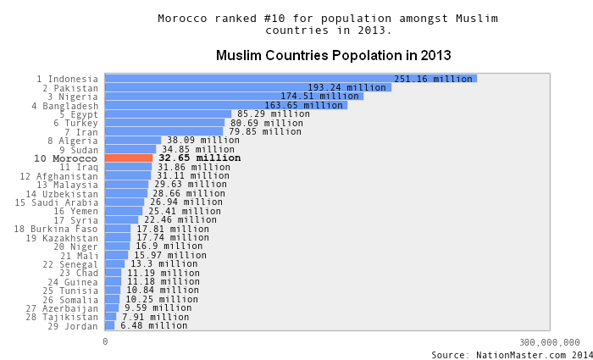
Do you know that there are 800 million Muslim women in the world?
The 3 primary challenges Muslim women face include:
1: Lack of Economic Empowerment
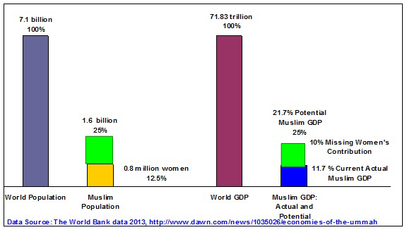
Two Facts:
- Muslim countries represent 25% of the world’s population, yet their GDP is 11.7% – about half of what it should be.
- The 13.3% disparity between the global Muslim population of 25% and actual GDP from Islamic countries (11.7%) is largely due to inequality and the lack of women’s participation in Islamic economies.
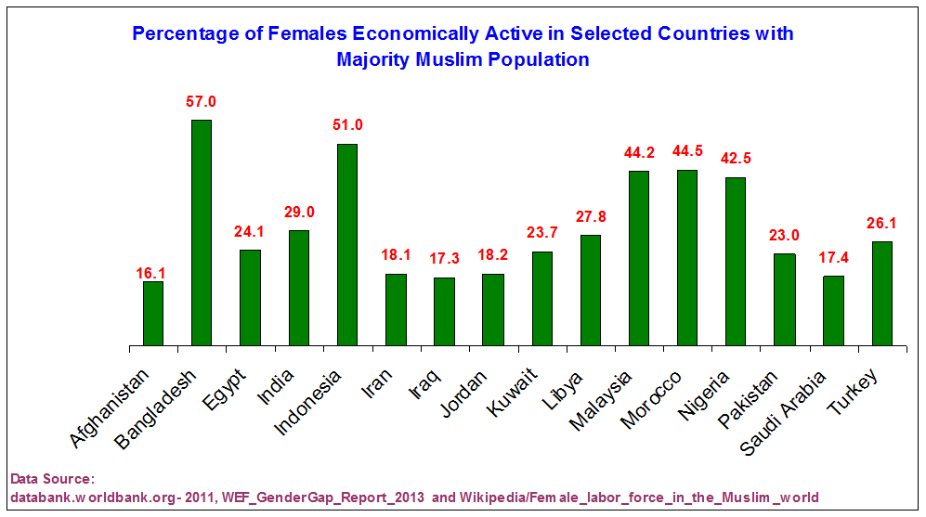
Labor Force Participation shows that only two of the selected Muslim Countries, i.e Bangladesh and Indonesia, have more than 50% of their females actively contributing to the work force.
2: Lack of Education
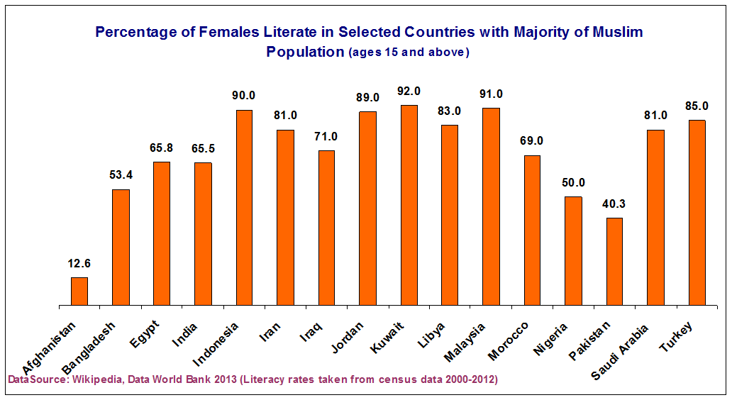
Percentages of females ages 15 and above who can read and write in selected Muslim countries is above 50 percent, except in Afghanistan and Pakistan where social and cultural restrictions still don’t allow girls to get an education.
3: Lack of Political Empowerment
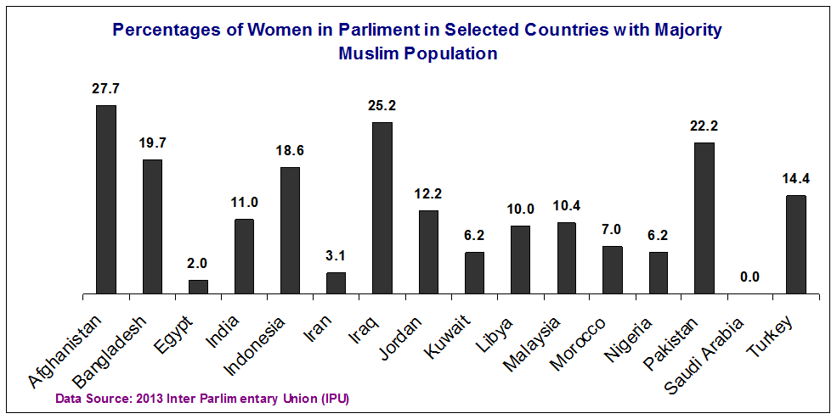
Political participation rates, as measured by women in parliament, are driven by quotas in South Asia, but otherwise lag.
- Limiting political participation in parliament dis-empowers Muslim women.
- It denies or inhibits their voice and vote.
- It robs them of their place and status at home and in the community.

Compiled and Presented By: Chennai Shia Youth Association (Www.ChennaiShiaYouth.Com)

